11.10: a) Since the wall is frictionless, the only vertical forces are the weights of the man and the ladder, and the normal force. For the vertical forces to balance, and the maximum frictional forces is 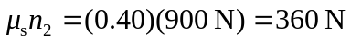(see Figure 11.7(b)). b) Note that the ladder makes contact with the wall at a height of 4.0 m above the ground. Balancing torques about the point of contact with the ground,

so 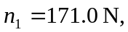 keeping extra figures. This horizontal force about must be balanced by the frictional force, which must then be 170 N to two figures. c) Setting the frictional force, and hence 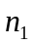, equal to the maximum of 360 N and solving for the distance x along the ladder,
so x = 2.70 m, or 2.7 m to two figures.

